Bài 4. Đăng nhập ajax

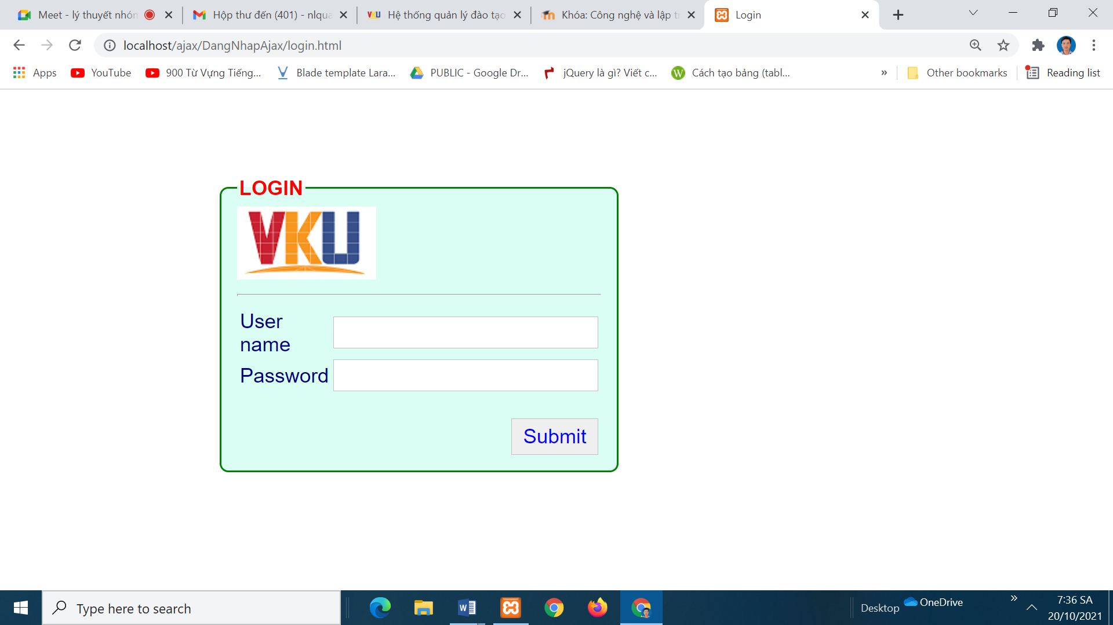

Bước 1. Tạo cơ sở dữ liệu . udn.sql

Bước 2. Tạo tệp connect.php

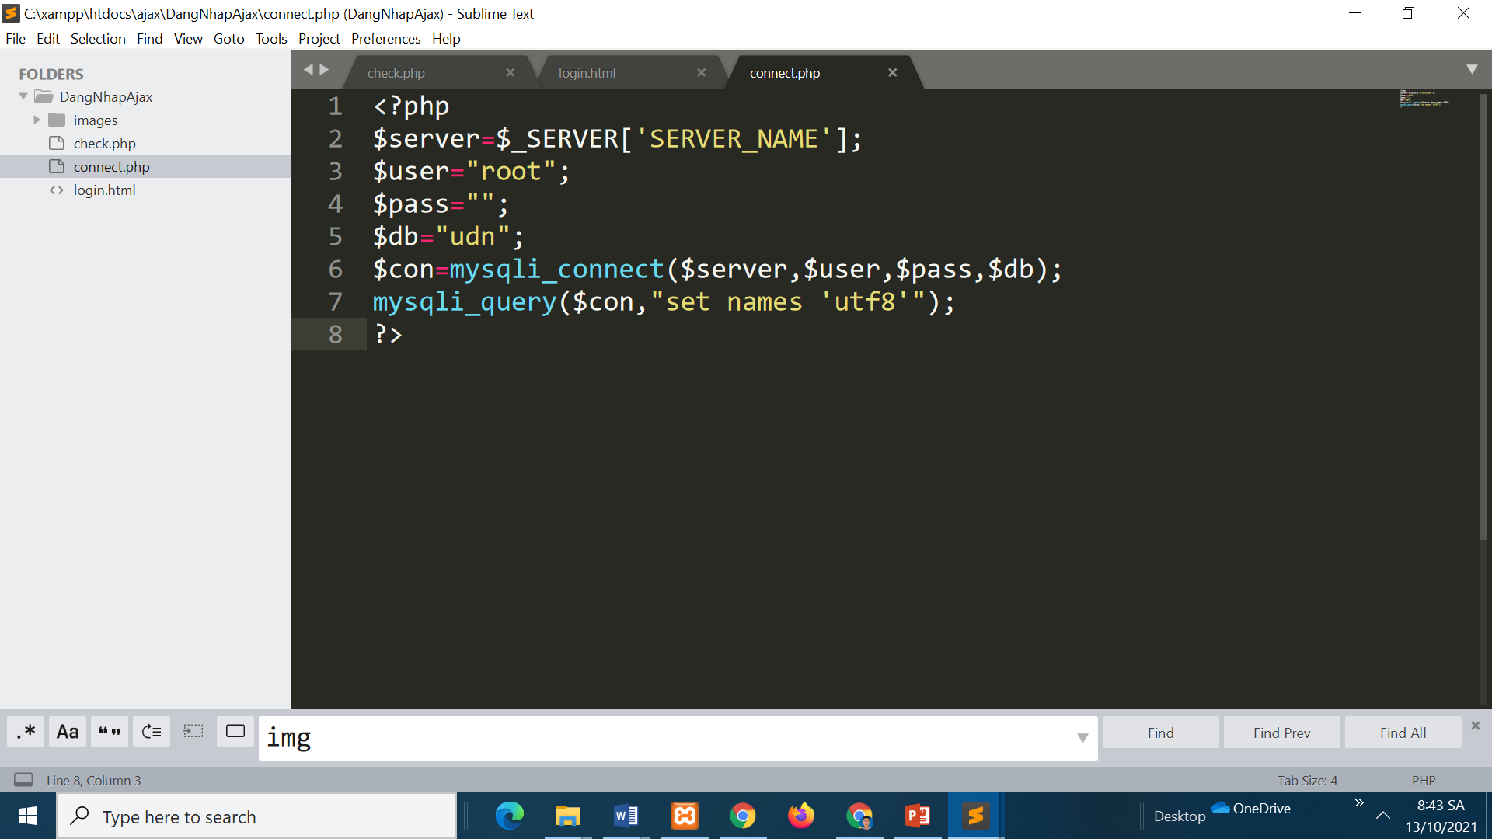

Bước 3. Tạp tệp check.php

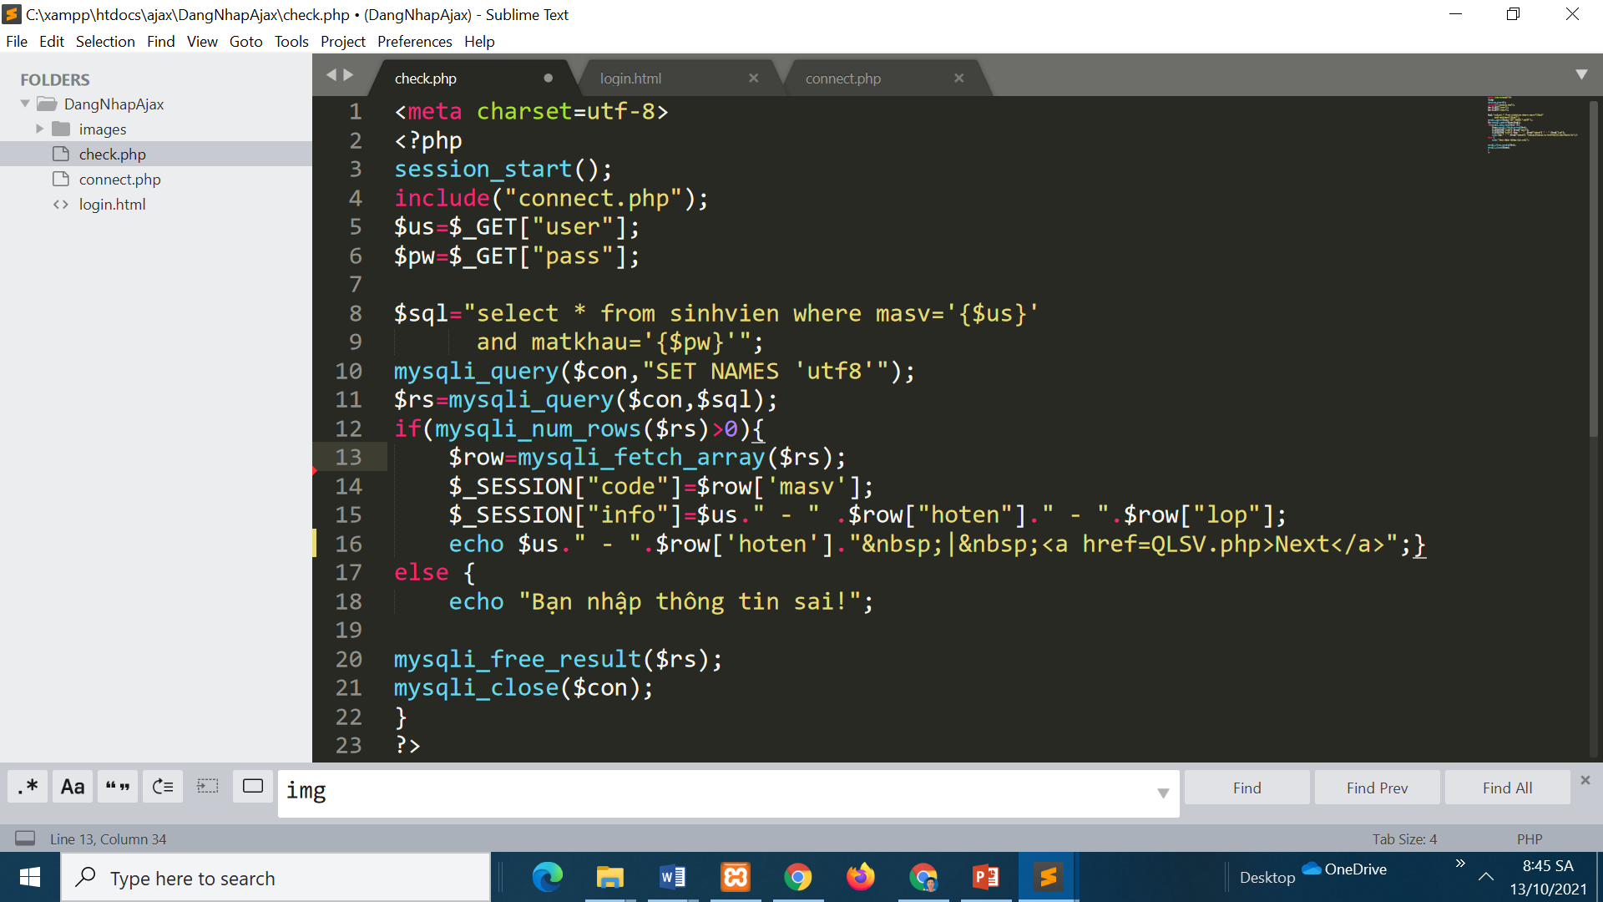

Bước 4. Tạo trang login.html

<!DOCTYPE html>

<html>

<head>

<title>Login</title>

<meta charset=utf-8>

<script src="https://ajax.googleapis.com/ajax/libs/jquery/3.6.0/jquery.min.js"></script>

<script>

$(document).ready(function(){

$("#sm").click(function(event){

$.get(

"check.php",

{user:$("#us").val(),pass:$("#pw").val()},

function(data){

$('#nt').css("display","block");

$("#nt").slideDown("slow");

$("#nt").html(data);

}

);

});

});

</script>

<style>

body{margin: 80px 200px;

font:normal 14pt Arial;

color:navy;}

input{border:solid 1px silver;

padding:3px;

font:normal 14pt Arial;

color:blue;padding: 3px 5px}

fieldset{border:solid 2px green;

border-radius:8px;

width:335px;

background-color:#DAFEF3;

}

div{width:335px;

border:solid 1px silver;

padding: 10px 15px;

font:normal 14pt Arial;

color:green;

background-color:yellow;

box-shadow: 2px 2px black;}

legend{color:red}

input[type=button]{float:right;padding:5px 10px}

</style>

</head>

<body>

<fieldset>

<img src='images/dhdn.gif' />

<hr>

<legend><b>LOGIN</b></legend>

<table>

<tr>

<td style="width:30%">User name</td>

<td style="width:70%">

<input type=text id=us onFocus="empty();">

</tr>

<tr>

<td>Password</td>

<td>

<input type=password id=pw>

</tr>

<tr>

<td colspan=2>

<br>

<!--input id=sm type=button value=Submit onClick="ajax();"-->

<input id=sm type=button value=Submit>

</tr>

</table>

</fieldset>

<br>

<div id=nt style='display:none;'>Notice:</div>

</body>

</html>